graph generation failure!

graph generation success!

Generated Graph (Adjacency Matrix):

[[0. 0. 0. 1. 0. 0. 1. 0. 0. 1.]

[0. 0. 0. 0. 0. 0. 1. 0. 0. 0.]

[0. 0. 0. 1. 0. 1. 1. 0. 1. 1.]

[1. 0. 1. 0. 0. 0. 1. 1. 0. 0.]

[0. 0. 0. 0. 0. 0. 1. 0. 0. 0.]

[0. 0. 1. 0. 0. 0. 0. 0. 0. 0.]

[1. 1. 1. 1. 1. 0. 0. 0. 0. 0.]

[0. 0. 0. 1. 0. 0. 0. 0. 0. 0.]

[0. 0. 1. 0. 0. 0. 0. 0. 0. 0.]

[1. 0. 1. 0. 0. 0. 0. 0. 0. 0.]]

Distances from each node to all other nodes:

From node 0: {0: 0, 3: 1, 6: 1, 9: 1, 2: 2, 7: 2, 1: 2, 4: 2, 5: 3, 8: 3}

From node 1: {1: 0, 6: 1, 0: 2, 2: 2, 3: 2, 4: 2, 9: 3, 5: 3, 8: 3, 7: 3}

From node 2: {2: 0, 3: 1, 5: 1, 6: 1, 8: 1, 9: 1, 0: 2, 7: 2, 1: 2, 4: 2}

From node 3: {3: 0, 0: 1, 2: 1, 6: 1, 7: 1, 9: 2, 5: 2, 8: 2, 1: 2, 4: 2}

From node 4: {4: 0, 6: 1, 0: 2, 1: 2, 2: 2, 3: 2, 9: 3, 5: 3, 8: 3, 7: 3}

From node 5: {5: 0, 2: 1, 3: 2, 6: 2, 8: 2, 9: 2, 0: 3, 7: 3, 1: 3, 4: 3}

From node 6: {6: 0, 0: 1, 1: 1, 2: 1, 3: 1, 4: 1, 9: 2, 5: 2, 8: 2, 7: 2}

From node 7: {7: 0, 3: 1, 0: 2, 2: 2, 6: 2, 9: 3, 5: 3, 8: 3, 1: 3, 4: 3}

From node 8: {8: 0, 2: 1, 3: 2, 5: 2, 6: 2, 9: 2, 0: 3, 7: 3, 1: 3, 4: 3}

From node 9: {9: 0, 0: 1, 2: 1, 3: 2, 6: 2, 5: 2, 8: 2, 7: 3, 1: 3, 4: 3}

From node FS 0: {0: -1, 3: 3, 6: 6, 9: 9, 2: 3, 7: 3, 1: 6, 4: 6, 5: 3, 8: 3}

From node FS 1: {1: -1, 6: 6, 0: 6, 2: 6, 3: 6, 4: 6, 9: 6, 5: 6, 8: 6, 7: 6}

From node FS 2: {2: -1, 3: 3, 5: 5, 6: 6, 8: 8, 9: 9, 0: 3, 7: 3, 1: 6, 4: 6}

From node FS 3: {3: -1, 0: 0, 2: 2, 6: 6, 7: 7, 9: 0, 5: 2, 8: 2, 1: 6, 4: 6}

From node FS 4: {4: -1, 6: 6, 0: 6, 1: 6, 2: 6, 3: 6, 9: 6, 5: 6, 8: 6, 7: 6}

From node FS 5: {5: -1, 2: 2, 3: 2, 6: 2, 8: 2, 9: 2, 0: 2, 7: 2, 1: 2, 4: 2}

From node FS 6: {6: -1, 0: 0, 1: 1, 2: 2, 3: 3, 4: 4, 9: 0, 5: 2, 8: 2, 7: 3}

From node FS 7: {7: -1, 3: 3, 0: 3, 2: 3, 6: 3, 9: 3, 5: 3, 8: 3, 1: 3, 4: 3}

From node FS 8: {8: -1, 2: 2, 3: 2, 5: 2, 6: 2, 9: 2, 0: 2, 7: 2, 1: 2, 4: 2}

From node FS 9: {9: -1, 0: 0, 2: 2, 3: 0, 6: 0, 5: 2, 8: 2, 7: 0, 1: 0, 4: 0}

From node Force 0: {0: 0, 1: 0, 2: 0, 3: 0.7777777777777777, 4: 0, 5: 0, 6: -0.5, 7: 0, 8: 0, 9: -1.0}

From node Force 1: {0: 0, 1: 0, 2: 0, 3: 0, 4: 0, 5: 0, 6: -0.4444444444444445, 7: 0, 8: 0, 9: 0}

From node Force 2: {0: 0, 1: 0, 2: 0, 3: 1.0, 4: 0, 5: -1.0, 6: -0.5, 7: 0, 8: -1.0, 9: -1.0}

From node Force 3: {0: 0.75, 1: 0, 2: 0.5, 3: 0, 4: 0, 5: 0, 6: -0.5, 7: -1.0, 8: 0, 9: 0}

From node Force 4: {0: 0, 1: 0, 2: 0, 3: 0, 4: 0, 5: 0, 6: -0.4444444444444445, 7: 0, 8: 0, 9: 0}

From node Force 5: {0: 0, 1: 0, 2: -0.7222222222222223, 3: 0, 4: 0, 5: 0, 6: 0, 7: 0, 8: 0, 9: 0}

From node Force 6: {0: -0.75, 1: -1.0, 2: -0.5, 3: -0.75, 4: -1.0, 5: 0, 6: 0, 7: 0, 8: 0, 9: 0}

From node Force 7: {0: 0, 1: 0, 2: 0, 3: -1.1388888888888888, 4: 0, 5: 0, 6: 0, 7: 0, 8: 0, 9: 0}

From node Force 8: {0: 0, 1: 0, 2: -0.7222222222222223, 3: 0, 4: 0, 5: 0, 6: 0, 7: 0, 8: 0, 9: 0}

From node Force 9: {0: -1.1111111111111112, 1: 0, 2: -0.5, 3: 0, 4: 0, 5: 0, 6: 0, 7: 0, 8: 0, 9: 0}

[-0.7222222222222223, -0.4444444444444445, -2.5, -0.25, -0.4444444444444445, -0.7222222222222223, -4.0, -1.1388888888888888, -0.7222222222222223, -1.6111111111111112]

Edge: 0 -> 3 tension: -4.027777777777778

Edge: 0 -> 6 tension: -2.2222222222222223

Edge: 0 -> 9 tension: 1.8888888888888888

Edge: 1 -> 6 tension: -1.5555555555555556

Edge: 2 -> 3 tension: -5.75

Edge: 2 -> 5 tension: 0.22222222222222232

Edge: 2 -> 6 tension: -4.5

Edge: 2 -> 8 tension: 0.22222222222222232

Edge: 2 -> 9 tension: -1.1111111111111112

Edge: 3 -> 6 tension: -1.75

Edge: 3 -> 7 tension: 2.888888888888889

Edge: 4 -> 6 tension: -1.5555555555555556

======================================

[0, 0, 0, 1, 0, 1, 1, 0, 1, 1]

From node Force 0: {0: 0, 1: 0, 2: 0, 3: -0.7222222222222223, 4: 0, 5: 0, 6: -0.5, 7: 0, 8: 0, 9: -1.0}

From node Force 1: {0: 0, 1: 0, 2: 0, 3: 0, 4: 0, 5: 0, 6: -0.7222222222222223, 7: 0, 8: 0, 9: 0}

From node Force 2: {0: 0, 1: 0, 2: 0, 3: -0.5, 4: 0, 5: -1.0, 6: -0.5, 7: 0, 8: -1.0, 9: -1.0}

From node Force 3: {0: -0.75, 1: 0, 2: -0.5, 3: 0, 4: 0, 5: 0, 6: 0.5, 7: -1.0, 8: 0, 9: 0}

From node Force 4: {0: 0, 1: 0, 2: 0, 3: 0, 4: 0, 5: 0, 6: -0.7222222222222223, 7: 0, 8: 0, 9: 0}

From node Force 5: {0: 0, 1: 0, 2: -0.44444444444444464, 3: 0, 4: 0, 5: 0, 6: 0, 7: 0, 8: 0, 9: 0}

From node Force 6: {0: -0.75, 1: -1.0, 2: -0.5, 3: 0.75, 4: -1.0, 5: 0, 6: 0, 7: 0, 8: 0, 9: 0}

From node Force 7: {0: 0, 1: 0, 2: 0, 3: -0.8611111111111112, 4: 0, 5: 0, 6: 0, 7: 0, 8: 0, 9: 0}

From node Force 8: {0: 0, 1: 0, 2: -0.44444444444444464, 3: 0, 4: 0, 5: 0, 6: 0, 7: 0, 8: 0, 9: 0}

From node Force 9: {0: -0.8333333333333335, 1: 0, 2: -0.5, 3: 0, 4: 0, 5: 0, 6: 0, 7: 0, 8: 0, 9: 0}

[-2.2222222222222223, -0.7222222222222223, -4.0, -1.75, -0.7222222222222223, -0.44444444444444464, -2.5, -0.8611111111111112, -0.44444444444444464, -1.3333333333333335]

Edge: 0 -> 3 tension: -1.0277777777777777

Edge: 0 -> 6 tension: -2.2222222222222223

Edge: 0 -> 9 tension: 0.11111111111111116

Edge: 1 -> 6 tension: 0.22222222222222232

Edge: 2 -> 3 tension: -3.75

Edge: 2 -> 5 tension: -1.5555555555555554

Edge: 2 -> 6 tension: -4.5

Edge: 2 -> 8 tension: -1.5555555555555554

Edge: 2 -> 9 tension: -2.3333333333333335

Edge: 3 -> 6 tension: -6.75

Edge: 3 -> 7 tension: 1.1111111111111112

Edge: 4 -> 6 tension: 0.22222222222222232

======================================

/opt/homebrew/lib/python3.11/site-packages/networkx/drawing/nx_pylab.py:437: UserWarning: No data for colormapping provided via 'c'. Parameters 'cmap' will be ignored

node_collection = ax.scatter(

2024-03-24 21:35:13.373 Python[2192:64609] WARNING: Secure coding is not enabled for restorable state! Enable secure coding by implementing NSApplicationDelegate.applicationSupportsSecureRestorableS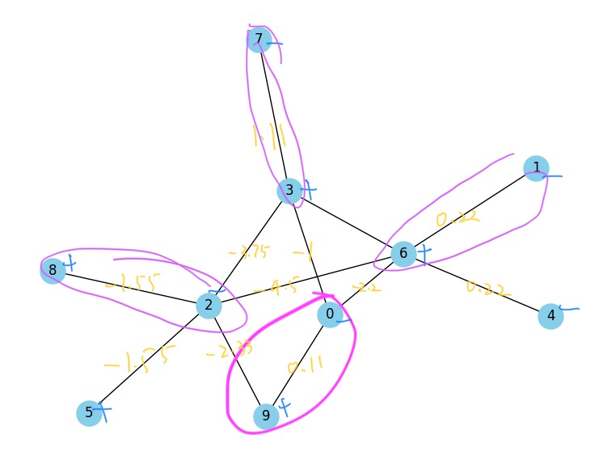

这个输出很合理